OPERATING SYSTEMS

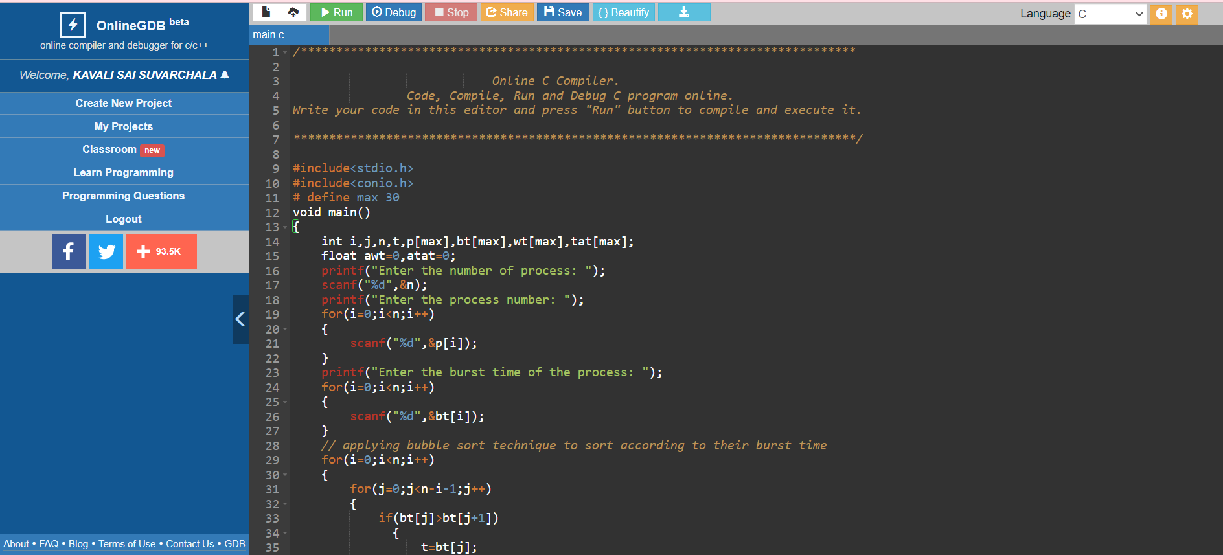

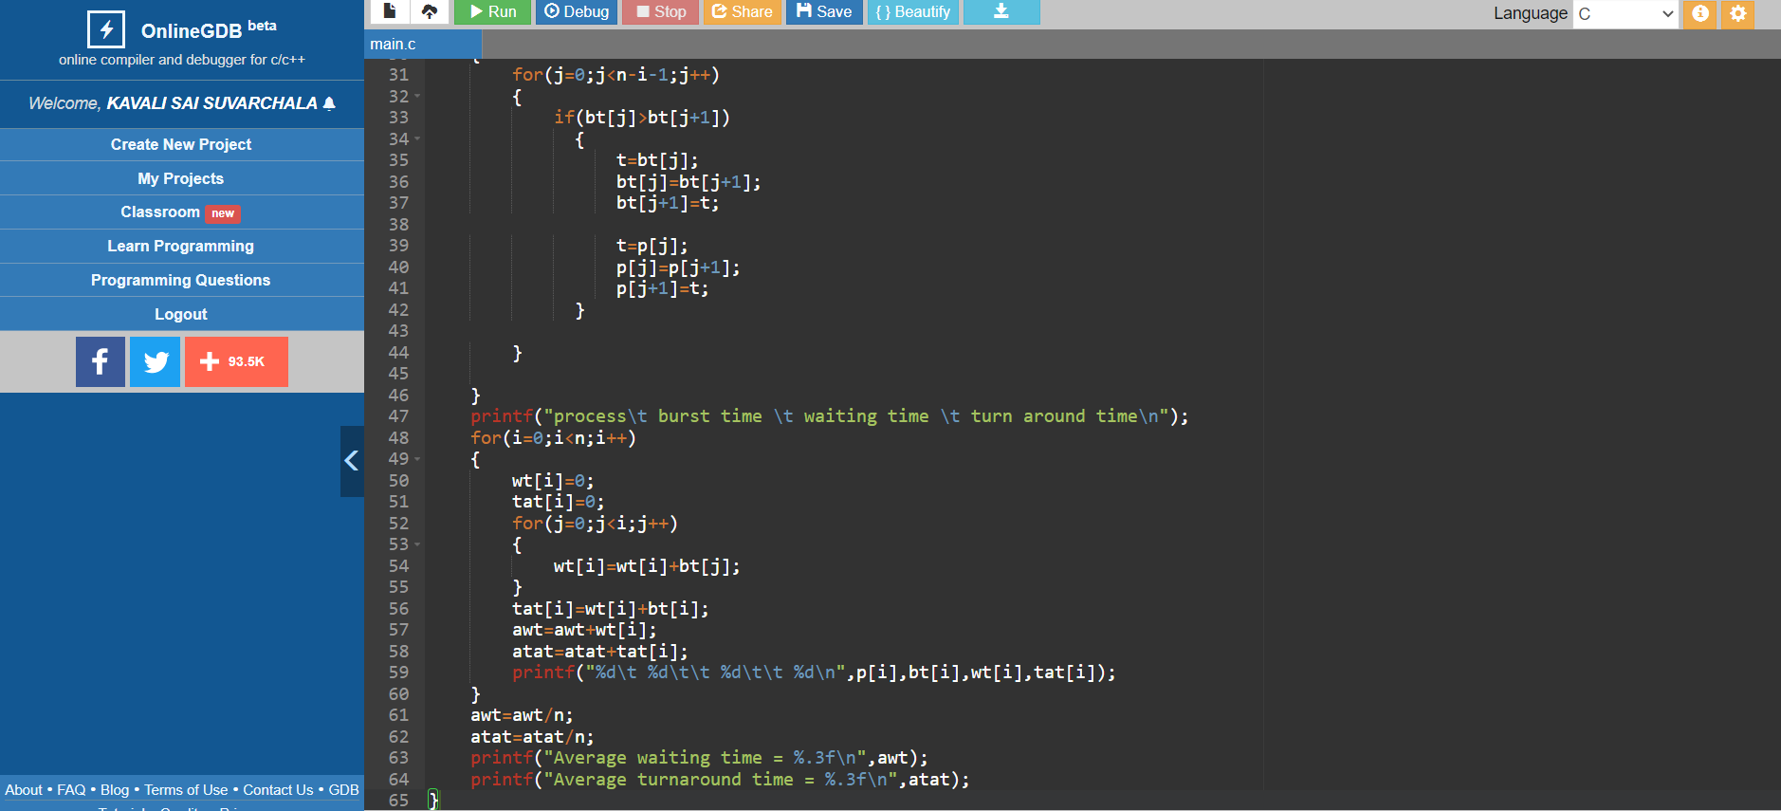

OUTPUT:

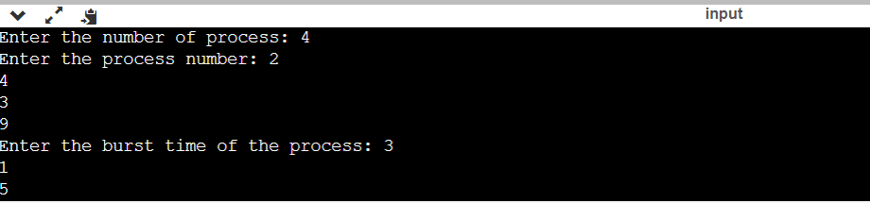

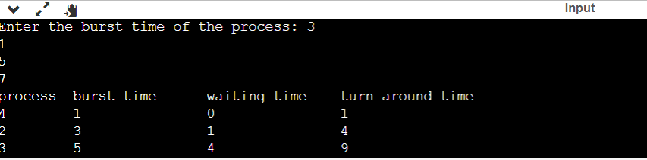

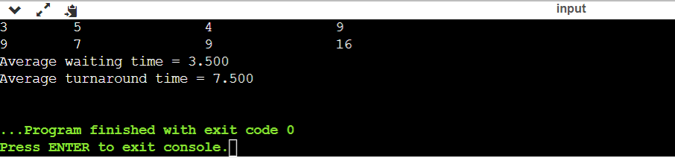

#include<stdio.h>

int main()

{

int n,bt[20],wt[20],tat[20],avwt=0,avtat=0,i,j;

printf("Enter total number of processes(maximum 20):");

scanf("%d",&n);in

printf("nEnter Process Burst Timen");

for(i=0;i<n;i++)

{

printf("P[%d]:",i+1);

scanf("%d",&bt[i]);

}

wt[0]=0;

for(i=1;i<n;i++)

{

wt[i]=0;

for(j=0;j<i;j++)

wt[i]+=bt[j];

}

printf("nProcessttBurst TimetWaiting TimetTurnaround Time");

for(i=0;i<n;i++)

{